Basic Of Web Programming

Practical-7

1-Develop XML document that will hold player (Like Cricket) collection with field for player-name, age, batting-average and highest-score, write suitable schema for the XML.

Code:

XML File :

<?xml version="1.0" encoding="UTF-8"?>

<PlayerCollection

xmlns:xsi="http://www.w3.org/2001/XMLSchema-instance"

xsi:noNamespaceSchemaLocation="schema1.xsd">

<Player>

<player-name>KL Rahul</player-name>

<player-age>30</player-age>

<betting-average>50</betting-average>

<highest-score>200</highest-score>

</Player>

<Player>

<player-name>KL Rahul</player-name>

<player-age>30</player-age>

<betting-average>50</betting-average>

<highest-score>200</highest-score>

</Player>

<Player>

<player-name>KL Rahul</player-name>

<player-age>30</player-age>

<betting-average>50</betting-average>

<highest-score>200</highest-score>

</Player>

<Player>

<player-name>KL Rahul</player-name>

<player-age>30</player-age>

<betting-average>50</betting-average>

<highest-score>200</highest-score>

</Player>

</PlayerCollection>

Schema File :

<?xml version="1.0" encoding="UTF-8" ?>

<xs:schema xmlns:xs="http://www.w3.org/2001/XMLSchema">

<xs:element name="PlayerCollection">

<xs:complexType>

<xs:sequence>

<xs:element name="Player" maxOccurs="unbounded">

<xs:complexType>

<xs:sequence>

<xs:element name="player-name" type="xs:string"/>

<xs:element name="player-age" type="xs:integer"/>

<xs:element name="betting-average" type="xs:integer"/>

<xs:element name="highest-score" type="xs:integer"/>

</xs:sequence>

</xs:complexType>

</xs:element>

</xs:sequence>

</xs:complexType>

</xs:element>

</xs:schema>

Output:

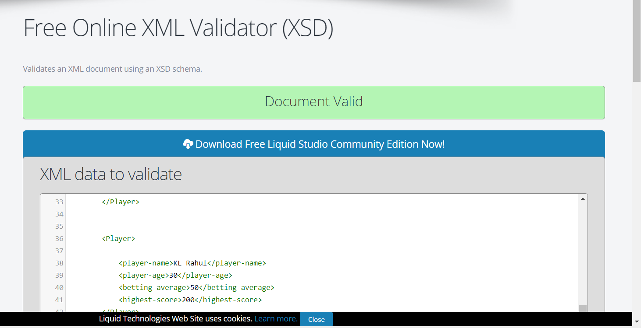

2-Write an XML file to store your semester mark sheet. Write an XSL file using XSLT to display it in XHTML table form.

Code:

XML File:

<?xml version="1.0" encoding="UTF-8"?>

<?xml-stylesheet type="text/xsl" href="xsl2.xsl"?>

<Marksheet>

<studentinfo>

<name>Parmar Rahul</name>

<mothername>Bhartiben</mothername>

<prn>2018033800122455</prn>

<seatno>304037</seatno>

</studentinfo>

<courses>

<co>

<name>em</name>

<am>th</am>

<ua>

<max>100</max>

<min>0</min>

<obt>80</obt>

</ua>

<ia>

<max>-</max>

<min>-</min>

<obt>-</obt>

</ia>

<total>

<max>100</max>

<min>0</min>

<obt>80</obt>

</total>

<sts>P</sts>

<rmk>E,C</rmk>

</co>

</courses>

<courses>

<co>

<name>em</name>

<am>th</am>

<ua>

<max>100</max>

<min>0</min>

<obt>80</obt>

</ua>

<ia>

<max>-</max>

<min>-</min>

<obt>-</obt>

</ia>

<total>

<max>100</max>

<min>0</min>

<obt>80</obt>

</total>

<sts>P</sts>

<rmk>E,C</rmk>

</co>

</courses>

<courses>

<co>

<name>em</name>

<am>th</am>

<ua>

<max>100</max>

<min>0</min>

<obt>80</obt>

</ua>

<ia>

<max>-</max>

<min>-</min>

<obt>-</obt>

</ia>

<total>

<max>100</max>

<min>0</min>

<obt>80</obt>

</total>

<sts>P</sts>

<rmk>E,C</rmk>

</co>

</courses>

<courses>

<co>

<name>em</name>

<am>th</am>

<ua>

<max>100</max>

<min>0</min>

<obt>80</obt>

</ua>

<ia>

<max>-</max>

<min>-</min>

<obt>-</obt>

</ia>

<total>

<max>100</max>

<min>0</min>

<obt>80</obt>

</total>

<sts>P</sts>

<rmk>E,C</rmk>

</co>

</courses>

<courses>

<co>

<name>em</name>

<am>th</am>

<ua>

<max>100</max>

<min>0</min>

<obt>80</obt>

</ua>

<ia>

<max>-</max>

<min>-</min>

<obt>-</obt>

</ia>

<total>

<max>100</max>

<min>0</min>

<obt>80</obt>

</total>

<sts>P</sts>

<rmk>E,C</rmk>

</co>

</courses>

<courses>

<co>

<name>em</name>

<am>th</am>

<ua>

<max>100</max>

<min>0</min>

<obt>80</obt>

</ua>

<ia>

<max>-</max>

<min>-</min>

<obt>-</obt>

</ia>

<total>

<max>100</max>

<min>0</min>

<obt>80</obt>

</total>

<sts>P</sts>

<rmk>E,C</rmk>

</co>

</courses>

<courses>

<co>

<name>em</name>

<am>th</am>

<ua>

<max>100</max>

<min>0</min>

<obt>80</obt>

</ua>

<ia>

<max>-</max>

<min>-</min>

<obt>-</obt>

</ia>

<total>

<max>100</max>

<min>0</min>

<obt>80</obt>

</total>

<sts>P</sts>

<rmk>E,C</rmk>

</co>

</courses>

<total>175</total>

<grandtotal>2357</grandtotal>

<per>75</per>

</Marksheet>

XSL File:

<?xml version="1.0" encoding="UTF-8"?>

<xsl:stylesheet version="1.0" xmlns:xsl="http://www.w3.org/1999/XSL/Transform">

<xsl:output method="html"/>

<xsl:template match="/">

<html xmlns="http://www.w3.org/1999/xhtml">

<body style="background: white;margin: 0 200px;padding: 0;color: black;">

<h1 style="margin: 20px;text-align: center;">

The Maharaja Sayajirav University of Baroda</h1>

<h3 style="text-align: center;">Vadodara-390002,Gujarat,India</h3>

<hr style="background: white;margin: 20px">

</hr>

<table border="1">

<thead>

<tr>

<th rowspan="2"> Course Name</th>

<th rowspan="2">AM</th>

<th colspan="3"> UA</th>

<th colspan="3"> IA</th>

<th colspan="3"> Total</th>

<th rowspan="2">Sts</th>

<th rowspan="2">Rmk</th>

</tr>

<tr>

<th>MAX</th>

<th>MIN</th>

<th>OBT</th>

<th>MAX</th>

<th>MIN</th>

<th>OBT</th>

<th>MAX</th>

<th>MIN</th>

<th>OBT</th>

</tr>

</thead>

<tbody>

<xsl:for-each select="Marksheet/courses/co">

<tr>

<td><xsl:value-of select="name"> </xsl:value-of></td>

<td><xsl:value-of select="am"> </xsl:value-of></td>

<td><xsl:value-of select="ua/max"> </xsl:value-of></td>

<td><xsl:value-of select="ua/min"> </xsl:value-of></td>

<td><xsl:value-of select="ua/obt"> </xsl:value-of></td>

<td>-</td>

<td>-</td>

<td>-</td>

<td><xsl:value-of select="total/max"> </xsl:value-of></td>

<td><xsl:value-of select="total/min"> </xsl:value-of></td>

<td><xsl:value-of select="total/obt"> </xsl:value-of></td>

<td><xsl:value-of select="sts"> </xsl:value-of></td>

<td><xsl:value-of select="rmk"> </xsl:value-of></td>

</tr>

</xsl:for-each>

<tr>

<th colspan="5">Total</th>

<th ><xsl:value-of select="Marksheet/total"></xsl:value-of></th>

<th colspan="5"></th>

<th><xsl:value-of select="Marksheet/total"></xsl:value-of></th>

<th colspan="2"></th>

</tr>

<tr>

<td colspan="14">

Grand Total: <xsl:value-of select="Marksheet/grandtotal"></xsl:value-of> out of 1400 Percentage: <xsl:value-of select="Marksheet/per"></xsl:value-of> %

</td>

</tr>

<tr>

<td colspan="14">

Abbreviations:IA

</td>

</tr>

</tbody>

</table>

</body>

</html>

</xsl:template>

</xsl:stylesheet>

Output:

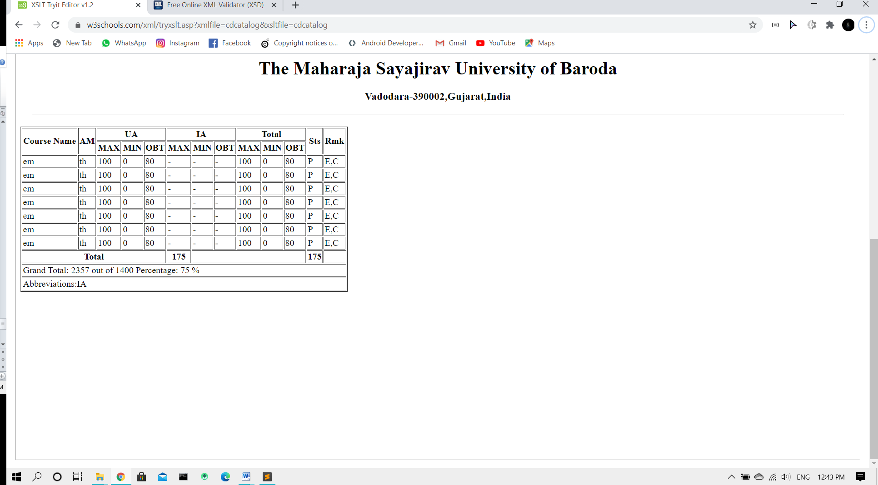

3-Develop an XML document that will hold a book collection with fields for book name, author, ISBN number and quantity. Write suitable schema for the XML.

Code:

XML File:

<?xml version="1.0" encoding="UTF-8"?>

<BookCollection xmlns:xsi="http://www.w3.org/2001/XMLSchema-instance"

xsi:noNamespaceSchemaLocation="schema1.xsd">

<Book>

<name>DR amin</name>

<auther>marc sim</auther>

<ISBN-number>12314</ISBN-number>

<quantity>10</quantity>

</Book>

<Book>

<name>DR amin</name>

<auther>marc sim</auther>

<ISBN-number>12314</ISBN-number>

<quantity>10</quantity>

</Book>

<Book>

<name>DR amin</name>

<auther>marc sim</auther>

<ISBN-number>12314</ISBN-number>

<quantity>10</quantity>

</Book>

<Book>

<name>DR amin</name>

<auther>marc sim</auther>

<ISBN-number>12314</ISBN-number>

<quantity>10</quantity>

</Book>

</BookCollection>

Schema File:

<?xml version="1.0" encoding="UTF-8" ?>

<xs:schema xmlns:xs="http://www.w3.org/2001/XMLSchema">

<xs:element name="BookCollection">

<xs:complexType>

<xs:sequence>

<xs:element name="Book" maxOccurs="unbounded">

<xs:complexType>

<xs:sequence>

<xs:element name="name" type="xs:string"/>

<xs:element name="auther" type="xs:string"/>

<xs:element name="ISBN-number" type="xs:integer"/>

<xs:element name="quantity" type="xs:integer"/>

</xs:sequence>

</xs:complexType>

</xs:element>

</xs:sequence>

</xs:complexType>

</xs:element>

</xs:schema>

Output:

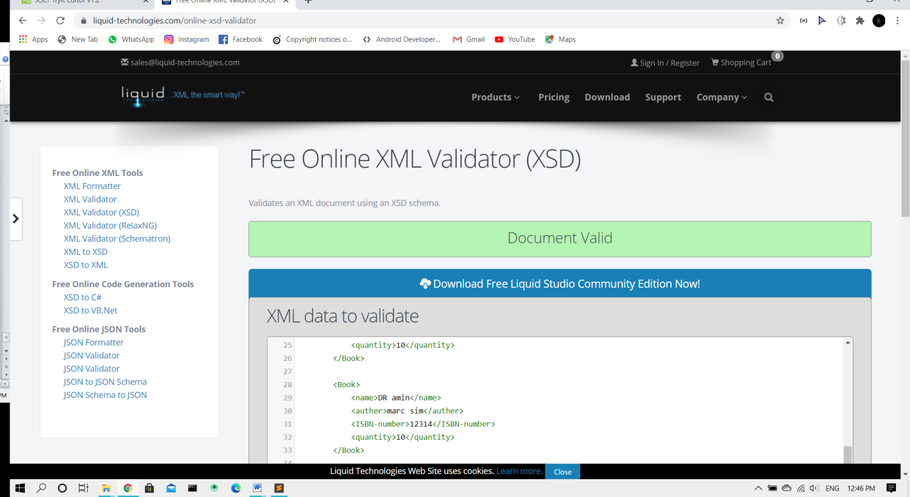

4-Write an XSL file to print list of products which has price< 300Rs. For item.xml file in tabular structure.

Code:

XML File:

<?xml version="1.0" encoding="UTF-8"?>

<?xml-stylesheet type="text/xsl" href="xsl4.xsl"?>

<Products>

<p>

<title>abc</title>

<price>500 </price>

</p>

<p>

<title>abcfd</title>

<price>200 </price>

</p>

<p>

<title>abasc</title>

<price>600 </price>

</p>

<p>

<title>agfbc</title>

<price>270 </price>

</p>

</Products>

XSL File:

<?xml version="1.0" encoding="UTF-8"?>

<xsl:stylesheet version="1.0" xmlns:xsl="http://www.w3.org/1999/XSL/Transform">

<xsl:template match="/">

<html xmlns="http://www.w3.org/1999/xhtml">

<body>

<h1>Products Which is less then 300 in price</h1>

<table border="1">

<tr>

<th>Product Title</th>

<th>Price</th>

</tr>

<xsl:for-each select="Products/p[price &lt; '300']">

<tr>

<td><xsl:value-of select="title"></xsl:value-of></td>

<td><xsl:value-of select="price"></xsl:value-of></td>

</tr>

</xsl:for-each>

</table>

</body>

</html>

</xsl:template>

</xsl:stylesheet>

Output:

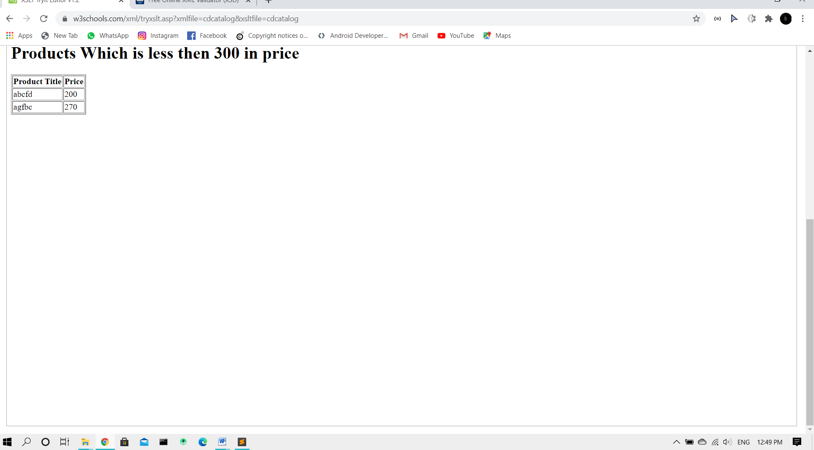

5-Develop XML File for book record and also write XSL for it to display in table format.

Code:

XML File:

<?xml version="1.0" encoding="UTF-8"?>

<?xml-stylesheet type="text/xsl" href="xsl5.xsl"?>

<BookCollection>

<Book>

<name>ert fgd</name>

<auther>dgf sim</auther>

<ISBN-number>12314364</ISBN-number>

<quantity>1</quantity>

</Book>

<Book>

<name>xxv cxv</name>

<auther>marc dfg</auther>

<ISBN-number>54612314</ISBN-number>

<quantity>17</quantity>

</Book>

<Book>

<name>Dxvcn</name>

<auther>er fdg</auther>

<ISBN-number>3612314</ISBN-number>

<quantity>10</quantity>

</Book>

<Book>

<name>Dxcvg</name>

<auther>hggf rtet</auther>

<ISBN-number>15232314</ISBN-number>

<quantity>20</quantity>

</Book>

</BookCollection>

XSL File:

<?xml version="1.0" encoding="UTF-8"?>

<xsl:stylesheet version="1.0" xmlns:xsl="http://www.w3.org/1999/XSL/Transform">

<xsl:template match="/">

<html xmlns="http://www.w3.org/1999/xhtml">

<body>

<h1>Book Record</h1>

<table border="1">

<tr>

<th>name</th>

<th>auther</th>

<th>isbn</th>

<th>quantity</th>

</tr>

<xsl:for-each select="BookCollection/Book">

<tr>

<td><xsl:value-of select="name"></xsl:value-of></td>

<td><xsl:value-of select="auther"></xsl:value-of></td>

<td><xsl:value-of select="ISBN-number"></xsl:value-of></td>

<td><xsl:value-of select="quantity"></xsl:value-of></td>

</tr>

</xsl:for-each>

</table>

</body>

</html>

</xsl:template>

</xsl:stylesheet>

Output:

